**GDD & TDD**

**Game Concept**

A horde wave survival game where you unlock more rooms as you slay more enemies, no actual coding implemented, only level design.

**Setting**

A Sci-fi underground facility containing living quarters, canteen, medical ward and research laboratories.

**Story**

A sci-fi Scientific Laboratory in the arctic that has experienced a breach from their experiment that was encased in Ice, causing unprecedented amounts of damage and chaos, and has recently been abandoned by all researchers, the bodies where not retrievable after the event but now, the bodies are nowhere to be seen.

**Research**

For research, I looked to a game called Viscera Cleanup Detail which is about a janitor company cleaning up after various breaches of containment in various Sci-fi laboratories, cleaning up dead bodies, sealing up bullet holes and replenishing/repairing various broken stuff found around the facility.

1-6: Medical examination ward for Alien Entities to study them

7-8: Lobby Area containing scanners and mounted turrets for defences

9-10: Armoury containing multiple mechs in case of a breach

11-13: Lounge Areas and Corridors

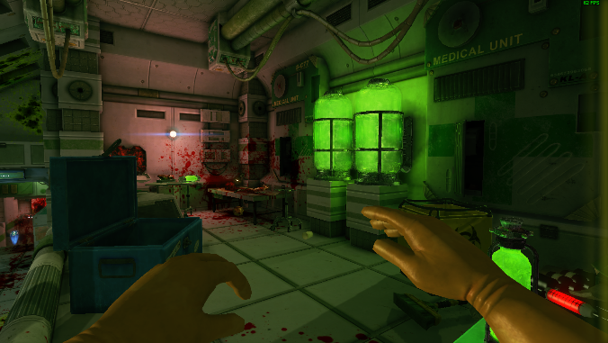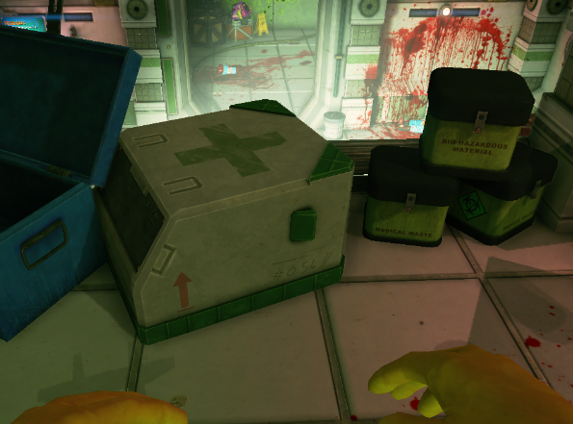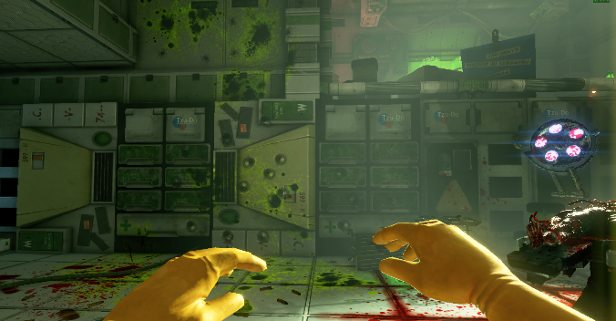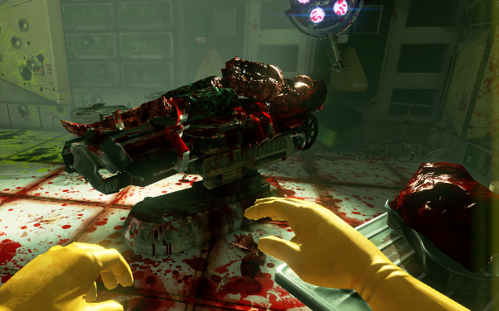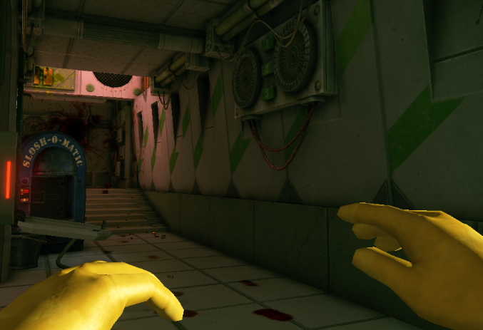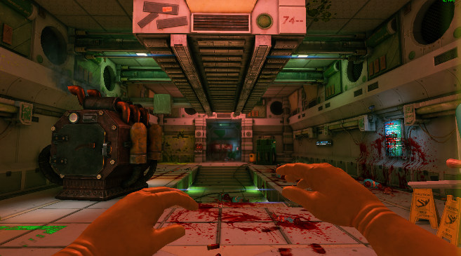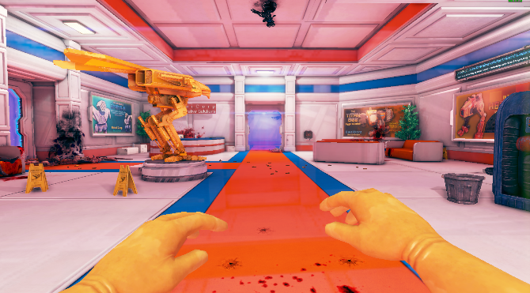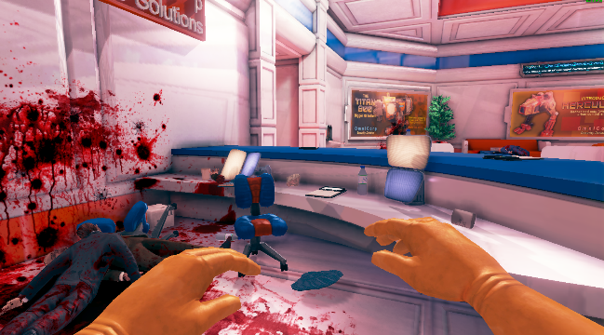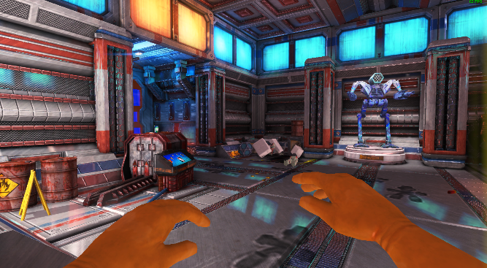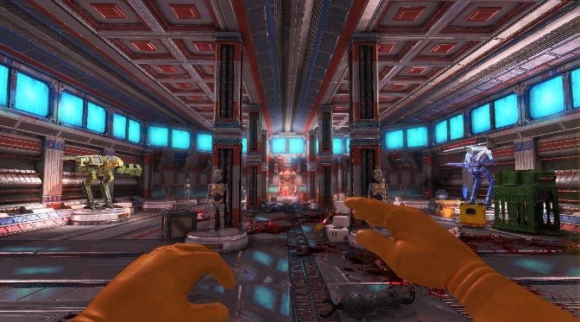

10

9

1

2

3

4

5

6

7

8

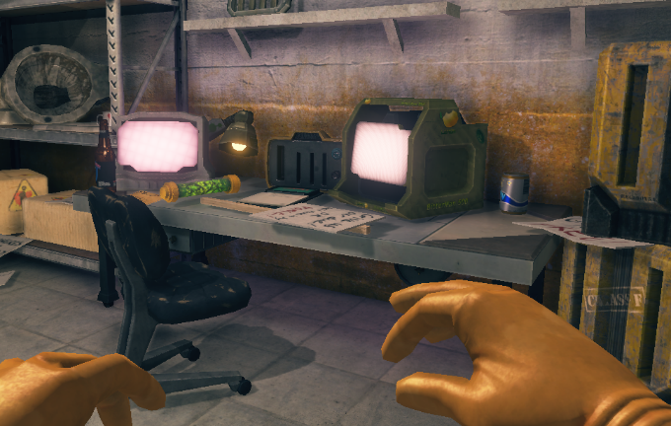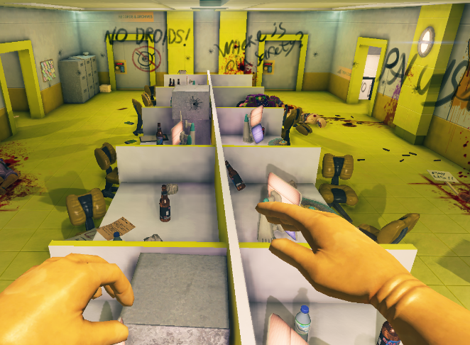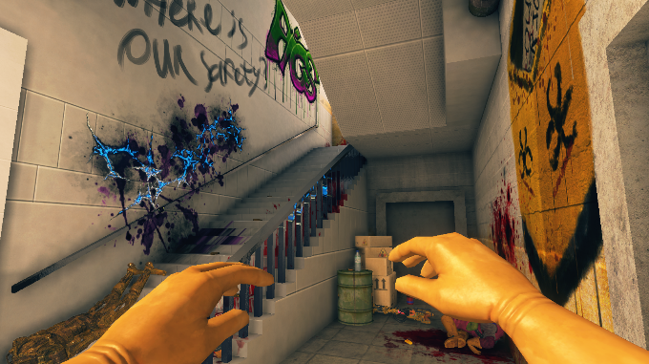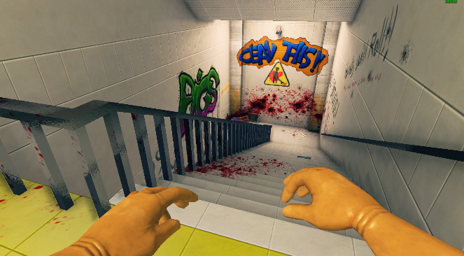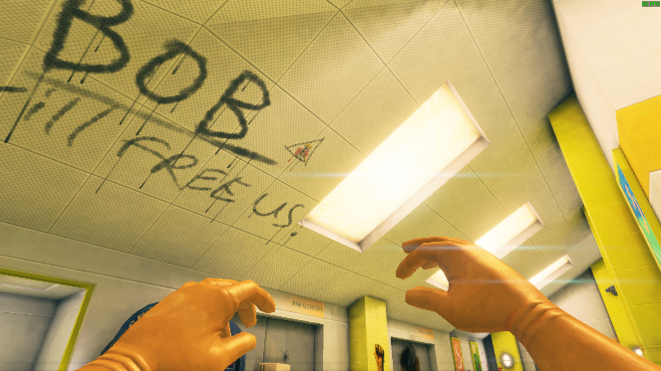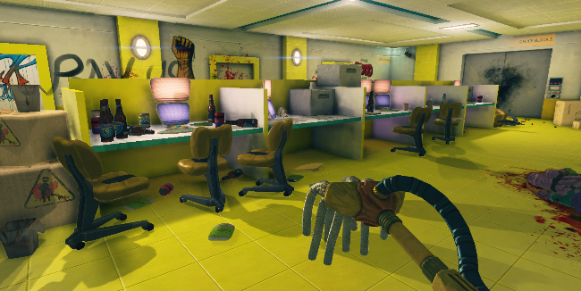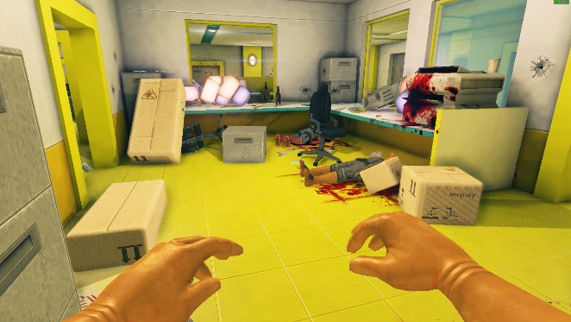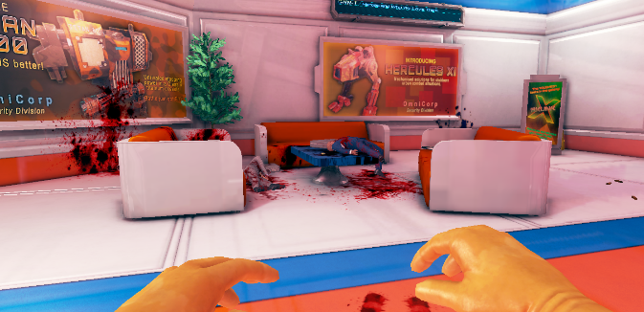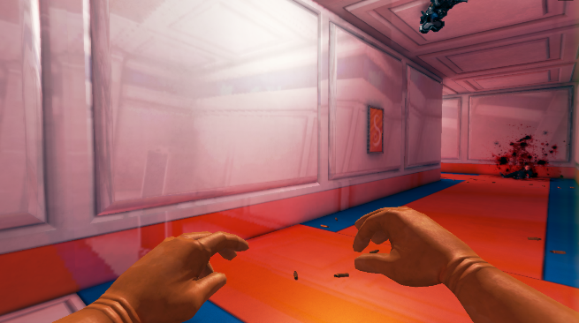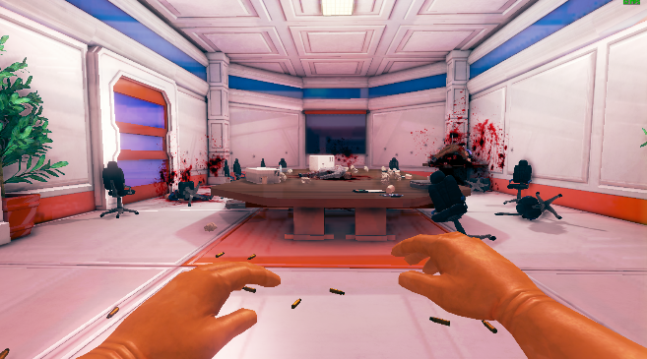

20

19

18

17

16

15

14

13

12

11

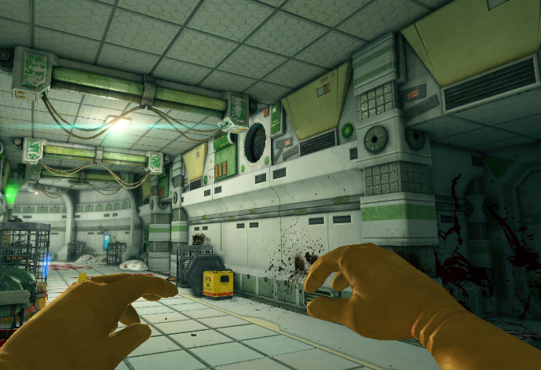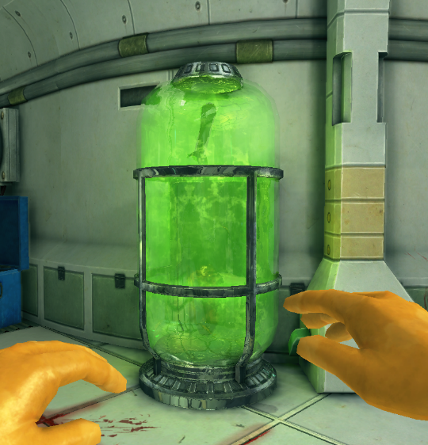

21

22

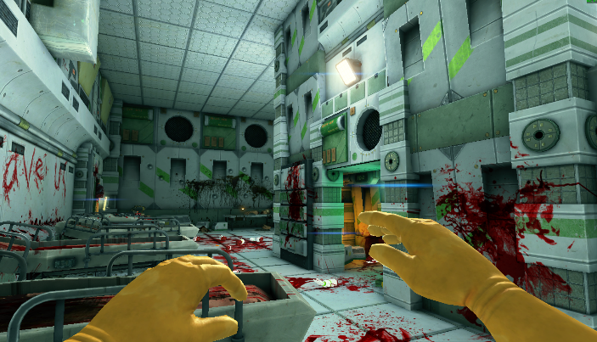

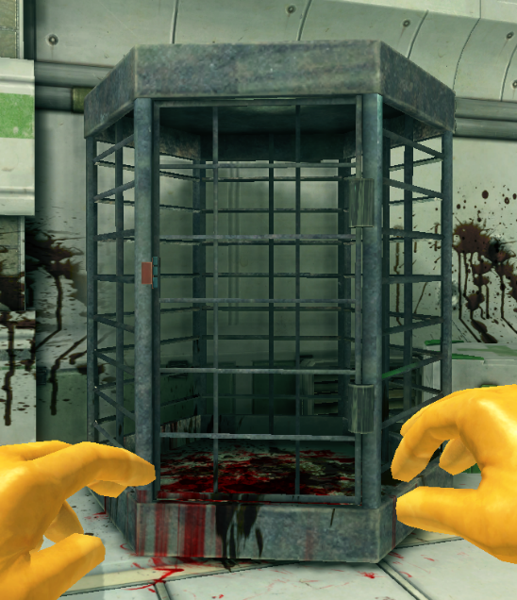

23

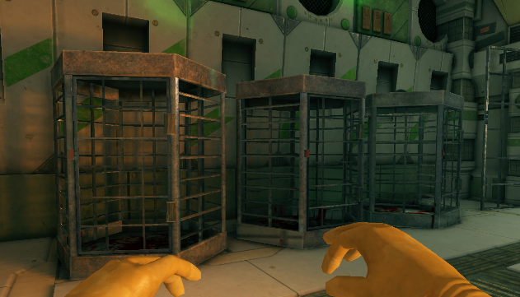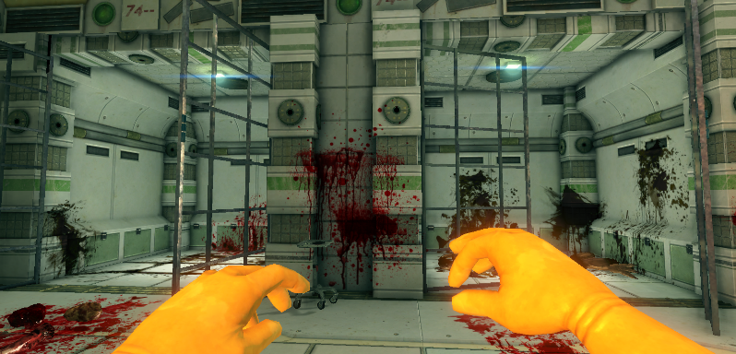

25

24

26

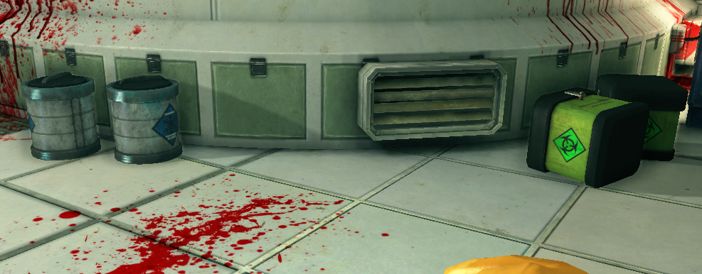

27